REVIT EXECUTION PLAN – For GSA project team only
Project number - Project name
Revit version | Revit 202- on Autodesk Forma ACC
Prepared by: | Digital Technology Team
Date Issued:
Model Manager :

1.0 Project structure and model strategy

1.1 ACC folder structure
The project is organized in ACC through the following folders:

Path | Models
Project Files / 0.0_ADMIN /
Project Files / 1.0_Teams / Architecture /

1.2 Model strategy
The ACC structure separates administration and architectural working files. The Control Model is stored in Project Files / 0.0_ADMIN /, while the Site Model, Central Model and reference model are stored in Project Files / 1.0_Teams / Architecture /
Each new project model must be linked to the Control Model using 'Auto – Origin to Internal Origin' and must acquire its coordinates, grids and levels before modelling begins. Consult the DT Team to confirm that new files are correctly shared and coordinated.

1.3 Shared Parameter file location
The Default shared parameter file location is in Project Files / 1.0_Teams / Architecture / 3.0_Common Links
Each GSA discipline (AR - LA – ID) should make a copy of the default shared parameter file into “Other” folder if they want to customize it for the project

2.0 Survey verification in AutoCAD
The survey verification and DWG preparation followed a structured process to ensure the geometry imported into Revit was clean, accurate and correctly positioned.

2.1 Project base point
The DWG was then moved in Revit so the identified corner aligned with the project origin (0,0,0), which is used as the building reference point. Coordinates were then acquired.
Project base point was identified at

The project has not been setup with real world coordinates and will require a geolocated survey to establish.

2.2 Grids setting
Grids were created from the project documentation and embedded in the Control Model to serve as a shared reference framework. All working models can copy monitor grids from the Control Model, ensuring consistency across the entire project team without the need for individual redefinition in each file. During the design phase, grids may be moved to suit design changes, project team should update the grids in the control model and then update in individual model.

3.0 Worksets and deployment to ACC
Worksets are established in the project.

Here is the list of worksets across all the models:
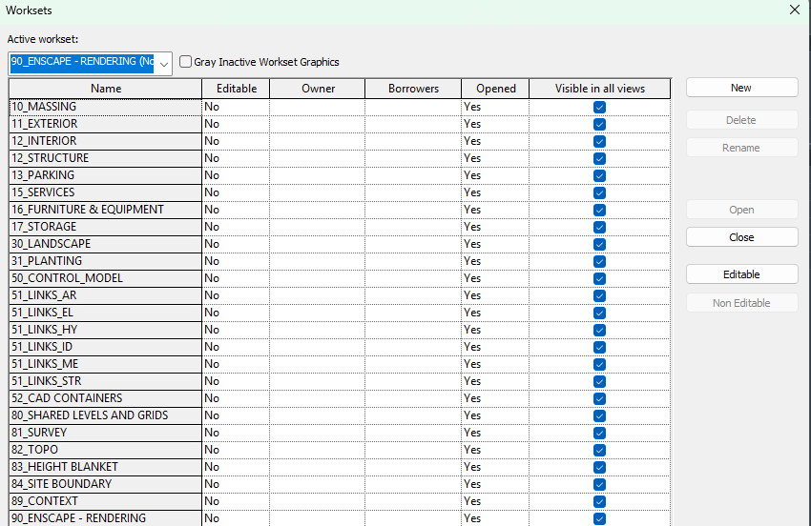

When modelling, ensure that each element is assigned to the correct workset. Link dwg or model files should be placed into appropriate worksets. Maintaining correct workset discipline from the outset ensures consistency across all models and supports a clean, predictable workflow for the entire team throughout all project stages.

4.0 Revit group strategy (Delete one)
Since the project involves repetitive floor layouts across multiple levels, Revit Groups will be used throughout the modelling process to streamline production.
Residential towers are highly repetitive: floor plates are typically copied level-to-level with minor variation. A disciplined model-separation and grouping strategy is essential to keep the file performant, edits propagating predictably, and the model splitable into separate files later if required.

Or
This project does not involve repetitive floor layouts across multiple levels. For that reason, is strongly suggested to not use model or detail groups in this project unless is strictly necessary. The use of group can slow your model, worsen performances and make daily work more complicated than it needs to be. Although groups are strongly discouraged, the following general rules apply where their use is unavoidable:

4.1 Grouping strategy
The floor plate is divided into five categories. Each category is modelled and grouped independently. The category can be divided as follows:

# | Group Category | Description | Modeling elements
1 | Facade | Consistent throughout levels. Sets the outer envelope all other walls must respect. | facade walls, doors, windows, balconies, balustrades, and any exterior-facing element
2 | Intertenancy walls (walls between units) (sometimes can also includes corridor walls) | May vary level-to-level but must always align to the facade module. | party walls between units only
3 | Internal unit walls | Grouped with the unit layout (finishes, joinery, FF&E). | internal partitions inside a unit, floor finishes, joinery, FF&E, doors
4 | Corridor walls | Usually unchanged between levels.  If impertinency wall already includes corridor wall, skip it in the project | corridor walls and corridor-side door leaves
5 | Core walls (lifts, fire stairs, services riser) | Unchanged between levels; structural priority. | core/shaft walls and doors that are part of the core
6 | Floor Slab | A typical concrete floor plate of each floor | 3D set down + cutouts + downpipe penetration holes or any cutouts/set down that cuts a void into the floor)  Finish floors should not be included

4.2 Group naming
Typical Group naming is as follows
<Building name>-<Group Name>_< Levell Start>-<Level End>
Include the level range the group spans, for easier tracking and scheduling:

1 | G-Unit_L05-L18 | (typical residential band)
2 | G-Facade_L05-L18
3 | G-Core_L01-Roof
4 | G-Intertenancy_L05-L10 | (if intertenancy varies mid-tower)
5 | G-Floor Slab-L10-L15

4.3 Workset & Versioning
- Assign each group to its matching workset (FACADE, INTERIORS, etc. per Section 9.1) for visibility control and selective loading.
- Groups can be edited as a separate Revit file via Edit Group → Save Group, then reloaded. This produces a versioned, archivable copy of the group — useful before any major typical-floor revision.

4.4 File separation
When a model grows beyond a manageable single-file size, the grouping strategy above lets you split cleanly:
- Save each group out as a standalone Revit file.
- Link the files back into the host model on the same workset structure.
- Facade, Core, and Corridor are the typical first candidates to split out, as they are the most stable and the most-referenced by other disciplines.

4.5 Good Model and Detail Group Practices
- Stay within one level per group. Every element inside a group must belong to the same level. Mixed-level groups corrupt floor-to-floor copy/paste and break schedules.
- Never press "Ungroup". If Revit prompts Fix Group or Create New Group Type, accept the new group type — but you must then update all instances you intended to change. Leaving half the floors on the old group type is the most common source of drift in residential models.
- Wall joining between groups is intentionally restricted. Walls from different groups should not join. This is correct behavior: a unit wall should never pass through an intertenancy wall, and an intertenancy wall should never pass through a core wall. If joins are appearing across groups, the group boundaries are wrong — fix the geometry, don't force the join.
- Use group only if it will be used 2 or more times (with an exception for the 5 group category above). Do not group if you are using it once. It is unnecessary and will slow the model.
- Do not create nested groups.
- Avoid attaching detail groups to model group if possible
- Consider creating LH/RH unit type if you need to mirror. Hatch pattern may not display correctly if you mirror groups
- Modelling elements is preferred over the use of filled regions. Filled regions can help to make a drawing presentable. It can also be covering up unresolved design.

4.6 Reference for further information (Remove if not Residential Project)
For more specific information about residential projects, please refer to the GroupGSA document "1401_Residential Projects Setup".

5.0 Model Coordination

5.1 Model Sharing
Models will be shared with other consultants via GSA ACC hub.
Weekly Auto Publish setup – Date: Time:
Project team will need to create package and share.
Project team will need to consume packages from other consultant via ACC.

5.2 Coordination ( review before issuing)
 | Status
Coordination Workflow | CD | SD | DD | IFT/IFC | SDC
PDF Drawings Review | Yes | Yes | Yes | Yes | N/A
“Overlaying” Revit Model | Yes | Yes | Yes | Yes | N/A
Clash Detection | No | No | No | No | N/A

5.3 Coordination view naming (For Model Coordination on ACC)
The Default Coordination view is:
COORD-GSA-ALL
This coordination view is set up to have all links + dwg imports turned off to have a clean Revit-only Geometry
It is recommended that the project lead communicate this naming convention and standards for consultant and how the view is set up when it comes to using Model Coordination on Autodesk Forma

6.0 Weekly model maintenance activities
- Open and audit the file
- Purge the file 3x or until there is no elements to purge. (see note below)
- Synchronise with the compact option selected.

Purging notes.
- On ACC, live Revit model files are versioned with each sync and each time you publish the files. You can access the versioned / backed up files to get back loadable families purged from your live models.
- For Concept / DA / SSDA / Early DD phase, use purge function to remove unused groups or families you are not using. Unselect all objects and select only the elements you want to purge.
- For other project phases, purge all elements by using the command 2-3 times or until there is no more purgeable elements.

